SmartCare v0.5 - Architecture and Refactoring Workbook
Week 8 student resource

Current Architecture Problems

Problem | Evidence | Impact | Refactoring
Duplicate Bookings | Spreadsheets and manual processes cause duplicate appointment bookings. | Double-booking time slots for GPs, causing scheduling chaos. | Introduce booking validation logic in the service layer to check practitioner availability.
Missing Patient Records | Difficulty locating physical patient records in paper files. | Wasted time and delayed patient consultations. | Implement a searchable repository layer for fast patient lookups by ID or name.
Tightly Coupled Code | Database queries written directly inside domain or UI classes. | Harder to test and maintain the application as it grows. | Separate concerns into clear Presentation, Service, Domain, and Repository layers.
Manual Cancellations | Appointment cancellations handled manually without tracking status properly. | Inconsistent appointment history and tracking errors. | Create a dedicated state management function for status updates in the domain layer.
Lack of Reports | Difficulty producing basic operational reports from spreadsheets. | Management cannot track clinic performance easily. | Add a reporting service layer to aggregate appointment data securely.

Layer Responsibilities
Layer | Responsibilities | Must not contain
Presentation | Handling user input, displaying UI screens, and showing responses to receptionists/GPs. | Business logic, direct database queries, or SQL commands.
Service | Coordinating application workflows, transaction handling, and use case orchestration. | UI components or direct persistence logic.
Domain | Containing core business models, validation rules, and state transitions (e.g., Patient, Appointment). | Database dependencies or external framework code.
Repository | Managing data access interfaces and abstracting data storage queries. | Direct UI rendering code or business decision rules.
Persistence | Managing actual database storage, tables, and connection drivers. | Business logic or validation rules.

Architecture Diagram
Insert SmartCare v0.5 architecture and dependency direction.
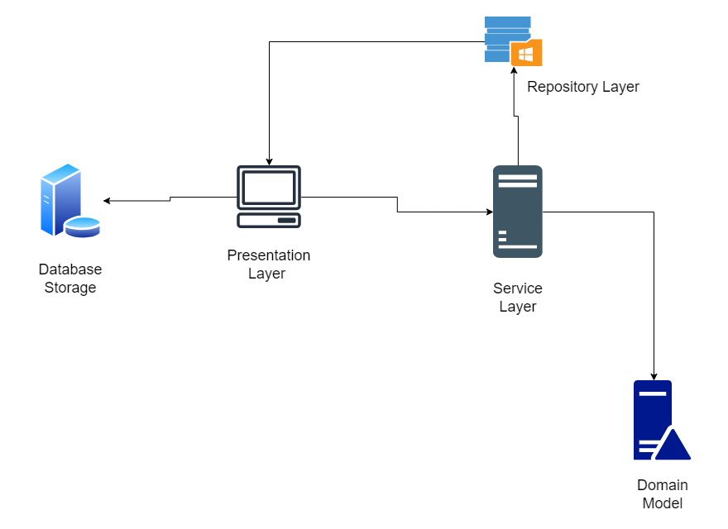
Figure: SmartCare Architecture Diagram

SOLID Review

Principle | Relevant? | Evidence | Decision
SRP (Single Responsibility) | Yes | Classes like Appointment and Patient managed separate domain tasks. | Enforced so each class has only one reason to change.
OCP (Open/Closed Principle) | Yes | Adding new report types or practitioner rules without breaking existing code. | Applied through abstract interfaces in repositories.
LSP (Liskov Substitution) | Yes | Subclasses or repository implementations must be replaceable without breaking the system. | Ensured consistent method signatures across data layers.
ISP (Interface Segregation) | Yes | Clients should not be forced to depend on methods they do not use. | Kept repository and service interfaces small and specific.
DIP (Dependency Inversion) | Yes | High-level service modules should depend on abstractions, not concrete details. | Used dependency injection for repository interfaces.

AI Architecture Review

AI suggestion | Observed problem? | Decision | Reason | Verification
Implement multi-tenant microservices architecture | No | Reject | Over-engineered and unnecessary for a small community clinic system. | Checked against project simplicity goals.
Separate presentation, service, and repository layers | Yes | Accept | Fixes tight coupling and improves code maintainability. | Reviewed layer dependency flow.
Add real-time WebSocket event broadcasting | No | Reject | Out of scope for a basic community clinic software brief. | Verified against functional requirements.
Introduce repository pattern for patient searches | Yes | Accept | Resolves difficulty locating patient records cleanly. | Tested data retrieval via interface mockups.
Add service layer validation to prevent duplicate bookings | Yes | Accept | Directly solves the core clinic problem of double bookings. | Tested overlapping appointment inputs.

